- DATA WRANGLING

First, we started by downloading all of the dataframes, renaming the columns to reflect the statistics contained within the data, and printing them so we could see when the data was collected. In doing so, we found that the data was not collected at the start of every year, but rather at different points throughout the year. To account for this, we had to interpolate the data to obtain one data point per year, for each dataframe. We achieved this by sorting the existing data by year, then creating a new array of integers reflecting each complete year that the data was collected, which we referred to as “target years.” Then, using the “scipy.interpolate,” we created a linear interpolation model fitted on the original data. After this, we inputted our “target years” into the interpolation model, and created a new dataframe containing the interpolated data and “target years.” In other words, we created a new dataframe containing the estimated values of each statistic at the start of every year that the original data was collected.
Special consideration was given to the USPV dataframe, as there were multiple data types and variables to consider, such that we could not use the exact same procedure as before. Instead, we started by counting the number of missing values for each row and sorting the rows from those with the least missing values to the most missing values. In doing so, when we dropped duplicate observations according to their descriptions using “drop_duplicates(subset=['description'], keep='first'),” we retained the more complete observations. We then truncated the decimal points on the “year” variable, and summed the fatalities for each year. We then created a dataframe with just the year and total number of fatalities, including even those years where there were no fatalities. However, we linearly interpolated the number of fatalities for those years where there were no fatalities, as the political instability index would be undefined if we did not.
Once the interpolation was done, we merged all of the datasets according to the year, and we began to calculate the political instability index. We inserted an additional column to our dataframe with the population on a year-by-year basis, which we interpolated from the original data that was collected every 5 years. Next, we calculated the 5-year moving averages for both the interpolated population and the number of fatalities, with the year of interest at the center of the 5-year range. We used this to compute the political instability index for every year, which equals the natural logarithm of the ratio of the moving average fatalities to the moving average population, scaled by a factor of one million. Then, we retained only the years for which all the data was available. Finally, we displayed the dataframe with only the years from 1901 to 1910.

- EXPLORATORY DATA ANALYSIS (for more graphs look at code file)

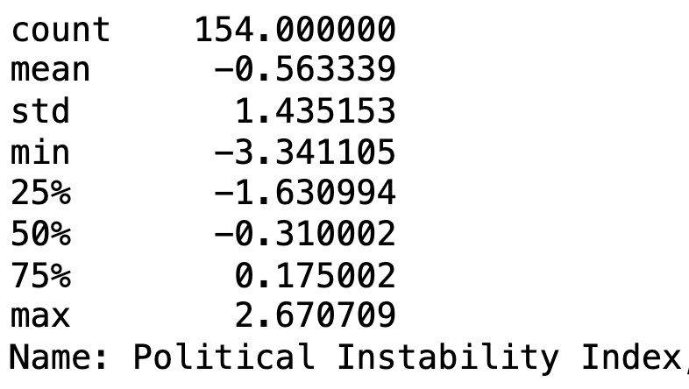
First, we discovered that the political instability index is left-skewed with a few high positive outliers. The mode of the political instability index distribution, indicated by the clear peak in the histogram, appears to be very close to 0. Since all the explanatory variables are also continuous, we chose to analyze their relationships using scatterplots. Generally, our analysis revealed a number of weak or nonexistent relationships: an extremely weak positive correlation between polarization and the political instability index, a very weak negative correlation between the percent total wealth and the political instability index, and no correlation between the political instability index and EVI. However, there was somewhat of a stronger negative correlation between life expectancy and the political instability index.

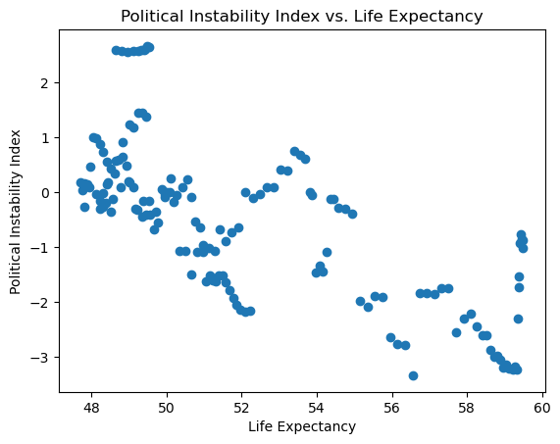
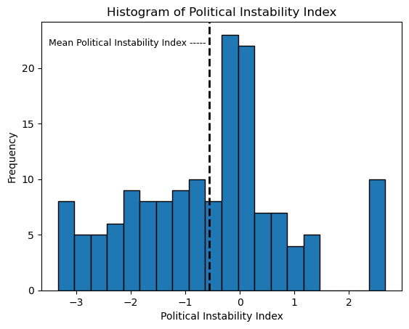

- FINDING THE BEST REGRESSOR

We evaluated five regression methods for predicting the political instability index: Linear Regression, LASSO regression, Ridge Regression, Decision Tree Regression, and Random Forest Regression. For each model, we used the same training and testing data, which we acquired by randomly selecting 70% of the dataset for training and 30% for testing. EVI, height, the percent of total wealth held by the top 1% by net worth, the percent of the population that is foreign-born, the wage-GDP ratio, and the polarization served as explanatory variables, while the dependent variable was the political instability index.
For the linear regression, we scaled the predictor variables and added a constant. After fitting the linear regression model on the training data, we got the coefficients and intercept. Next, we evaluated this model on our testing data, and assessed its performance using the mean squared error (MSE), mean absolute error (MAE), and R² score (which represents the proportion of the variance in the dependent variable that is predictable from the independent variables). We decided to use MSE for selecting the optimal hyperparameters and as one of three performance metrics because it measures the prediction accuracy by heavily penalizing larger errors, ensuring that our model prioritizes minimizing significant deviations.
For the LASSO and Ridge regressions, we used 10-fold cross-validation for 1,000 evenly spaced alpha values on a logarithmic scale between 10⁻⁴ and 10⁴, to find the optimal regularization strength that minimized the MSE (alpha_{LASSO} = 0.028, alpha_{RIDGE} = 3.88). Once the optimal alpha value was identified based on the training set, we fit each of the models, obtained their respective coefficients and intercept, and evaluated them according to the aforementioned performance metrics.
For the Decision Tree regression, we determined the best max_depth and ccp_alpha values using 10-fold cross-validation with the following ranges: max_depth: [None, 5, 10, 15, 20, 25, 30, 35, 40] and ccp_alpha: [0.0, 0.001, 0.01, 0.05, 0.1, 0.2, 0.3]. Similarly, for the Random Forest regression, we determined the best max_depth and n_estimators using 10-fold cross-validation with the following ranges: max_depth: [None, 5, 10, 15, 20, 25, 30, 35, 40] and n estimators: [10, 50, 100, 200, 300, 400, 500]. After identifying the max_depth (=5) and ccp_alpha (=0) values for the Decision Tree and the max_depth (=None) and n_estimators (=200) values for the Random Forest that minimized the training set MSE, we applied the model to the test set and evaluated it using MSE, MAE, and R² Score.
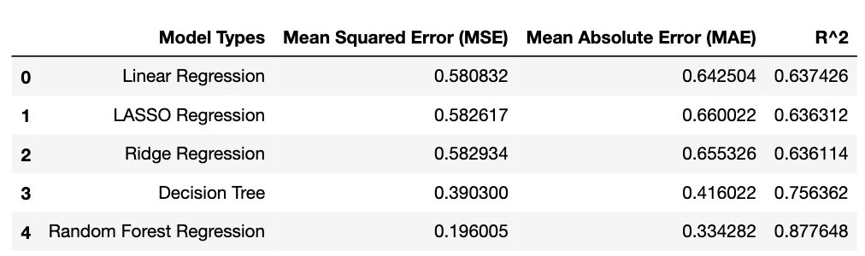
From our performance metrics, we see that the Random Forest Regressor was the best-performing model. This is because the Linear, LASSO, and Ridge regression models are only suitable for linear relationships, which may not properly represent the complex relationships between the independent and dependent variables as reflected in the exploratory analysis. Furthermore, compared to the decision tree regressor, the Random Forest Regressor can handle more complex relationships and reduce overfitting by averaging multiple decision trees.
To determine the best regressors, we examined the coefficients for the linear, LASSO, and ridge regression models, and the feature importance for the decision tree and random forest models. Feature importance in these tree-based models is calculated based on how much each feature contributes to reducing impurity in the tree. For the linear, LASSO, and ridge regression models, the EVI, percentage of foreign-born population, and life expectancy had the highest absolute coefficients, all above 0.5. In the decision tree and random forest models, life expectancy and polarization were identified as the most important features, with importance scores of 0.52 and 0.25 for the decision tree, and 0.34 and 0.3 for the random forest model, respectively.

- FINDING THE BEST DIMENSIONALITY REDUCTION

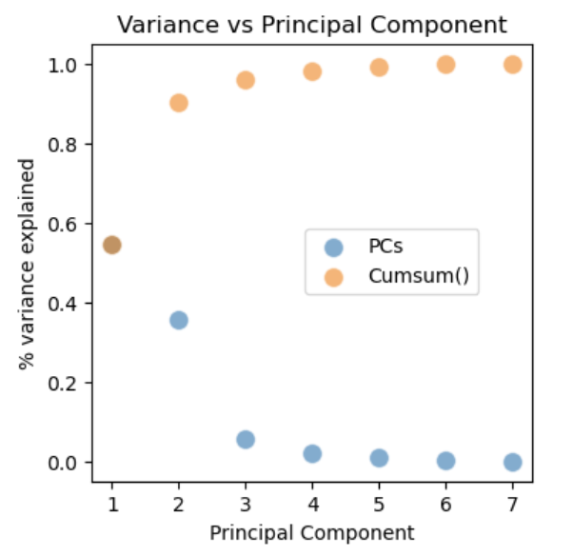
First, we performed Principal Component Analysis (PCA) on the scaled data, fitting a PCA model with the number of components equal to the number of original features. We then plotted the explained variance ratio and the cumulative explained variance ratio for each principal component, using a scatter plot to visualize the amount of variance each principal component explains. We choose 2 principal components because this explains around a 90% cumulative variance.
Subsequently, we conducted a PCA with 2 components on the scaled data. After obtaining the 2-component PCA data, we split it into training and test sets using a 70-30 split with the dependent variable being the instability index. We then applied the same methodology as earlier for the decision tree and random forest regression regressions on this PCA data set given that they were the best performing regressions that we found in part 3.
For the PCA Decision Tree Regressor, the optimal parameters were found to be an alpha of 0.01 and no maximum depth. This model yielded a testing MSE of 0.58, an MAE of 0.49, and an R² of 0.64. For the PCA Random Forest Regressor, the best parameters were determined to be no maximum depth (None) and 300 estimators. This model produced a testing MSE of 0.38, an MAE of 0.44, and an R² of 0.76. These performance metrics are lower than before the PCA which is consistent with expectations, considering that the two principal components explained approximately 90% of the variance. Similar to the non-PCA models, the PCA Random Forest Regressor outperformed the PCA Decision Tree Regressor.

- BEST DIMENSIONALITY REDUCTION FOR UNSUPERVISED CLASSIFICATION

We conducted a PCA with 2 components on the scaled data for all the previous features and also the instability index, since this was an unsupervised model. To determine the optimal number of clusters for K-means clustering, we used the elbow method, which involves finding the point where the curve of the sum of squared errors (SSE) versus the number of clusters bends sharply, indicating diminishing returns for adding more clusters. We identified that the optimal number of clusters is 4. In addition to evaluating the SSE, we assessed the model using the silhouette score, which measures how similar each data point is to its own cluster compared to other clusters. For our k=4 clusters, the silhouette score is 0.63, which is the highest score for any cluster number in our analysis, confirming the suitability of this cluster value.

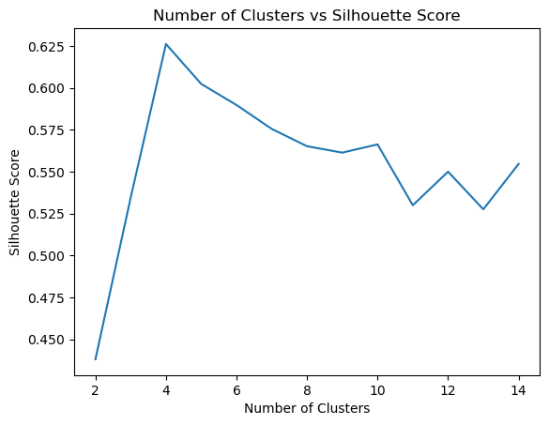
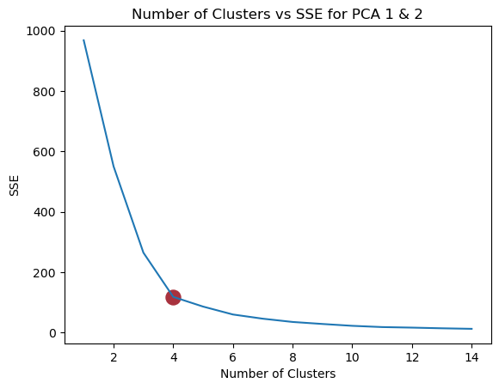

- EXPLORE THE CLUSTERS OF INSTABILITY SCORES
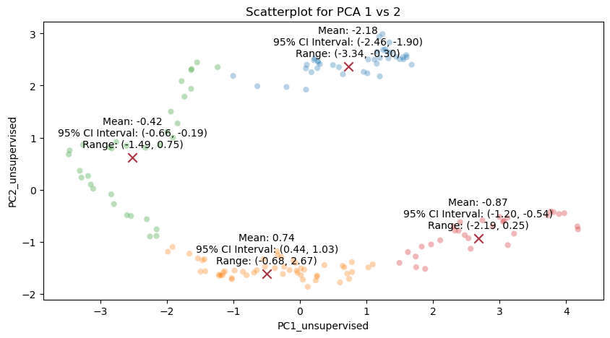
Using the PCA k-means classifier model from question 5, we created a scatterplot of the first two principal components, with points colored according to their cluster assignments, with the X indicating the center of the cluster. For each cluster, we found the range, 95% confidence interval, and the mean. Furthermore, we made a boxplot for the political instability index by each cluster.
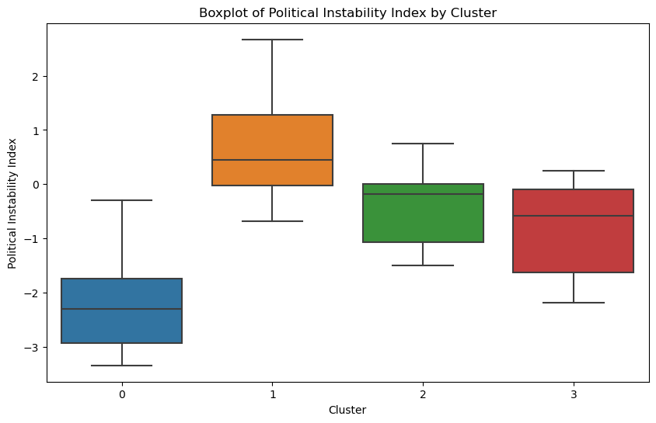
The scatterplot of the first two principal components shows distinct clusters with well-separated centers and varying spreads, indicating successful PCA dimensionality reduction and effective k-means clustering. While the means of the clusters fall within the range of other clusters, none of the means of the Political Instability Index for the clusters fall within the 95% confidence intervals of the other clusters, indicating distinct differences between them. The clusters show similar variances with comparable spreads of values. The IQRs and whisker lengths across all clusters indicate that the variances are relatively consistent.

7. REAL-LIFE PROBLEMS

Doctors and nurses have largely benefitted from recent technological advancements, as it enables them to deliver a higher quality of patient care. Neural networks, such as convolutional neural networks (CNN), have been used to improve medical image processing by identifying tumors that are still in their infancy and serving as a means of checking previous diagnoses. Given their high utility and potential impact, those making medical image processing CNN’s likely build hundreds to thousands of models, to try to deliver better results to users. While, in reality, the process for evaluating these models is likely very thorough and well thought out, developers must still be wary of falling victim to poor data science practices, especially when their work has implications for people’s health.
One of the most important considerations when evaluating a model is the choice of performance metric. For somebody evaluating thousands of CNN models at one time, it is very time-consuming to consider all the performance metrics for each and every model, so one might base the decision on a single commonly used metric: accuracy. However, this could be particularly harmful in the context of medical image processing, as the most accurate model does not necessarily have the highest recall score, which is important given how high the cost of type II error is. Additionally, precision remains somewhat important to consider, too, as nobody wants a model that predicts positives at such a high rate that the user ends up losing confidence or utility from it. This goes to show that interpreting model performance using one statistic alone does not always paint the full picture or produce the best outcomes, which is why one should mitigate it by always considering multiple statistics when selecting the best model.
While analyzing multiple statistics when selecting a model helps mitigate certain problems, it is not a cure-all. It is possible that a CNN could be overfit and/or biased towards the dataset it was tested and trained on, such that it has strong performance metrics but poor reproducibility on other datasets, regardless of the number of models in question. This could happen for a number of different reasons, such as if the dataset used for testing and training exhibited some form of bias (i.e. only contained scans with tumors appearing in a particular location) or the model did not have a regularization term to penalize overfitting. This could produce lots of harm, as releasing models that cannot perform well on real-world data might confirm incorrect diagnoses, which has life or death implications. To avoid overfitting and biased results, and thereby avoid the aforementioned dangers, one should select models that have been trained on complete and representative samples of data and to make sure that there are measures in place to prevent overfitting, such as a penalization term.

